Drone saw

Make a drone with a chainsaw that can cut small tree limbs. All electric. Can be oscillating or a standard chainsaw.

Oscillating chainsaw. 2 mechanisms

Cylindrical cam slider

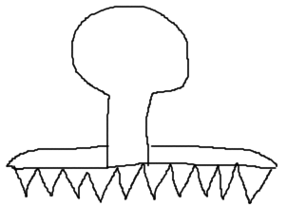

Reference: <https://www.youtube.com/watch?v=8c4hOlaGS-U>

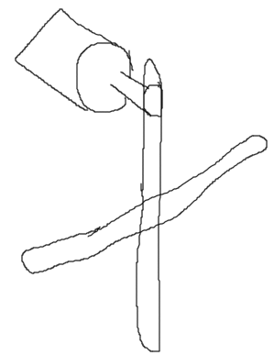Scotch and yoke

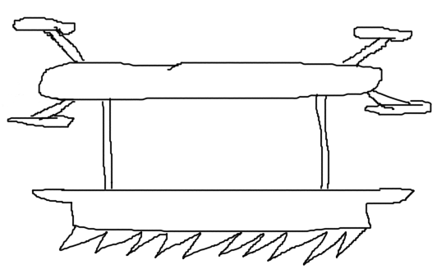

A DC motor spins the yoke and causes the saws to go back and forth. May need a second one that goes in opposite direction. Newton’s 3rd law of motion.

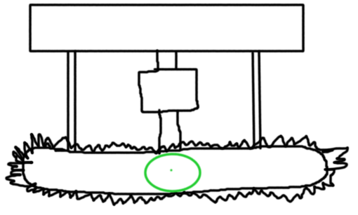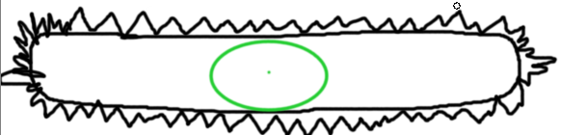

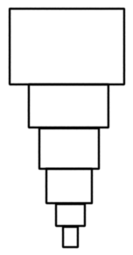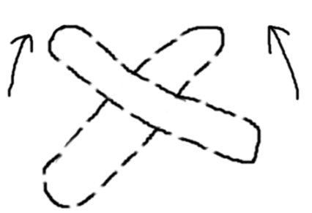

Buttons:

-Ascend

-Descend

-left stick:

-move left/right/

-forward/backward

-right stick:

- spin left/right

-Hover

-Activate/deactivate saw

A telescoping housing to raise and lower the saw. The wiring will spiral up and down so it can uncoil and collapse into itself.

These will change the angle of the blade.

A chainsaw is powered by a dc motor in the middle for balance. Problem is that blade may be too short for mid-sized branches.